Entire Rows and Columns

1. The following code line selects the entire sheet.

Cells.Select

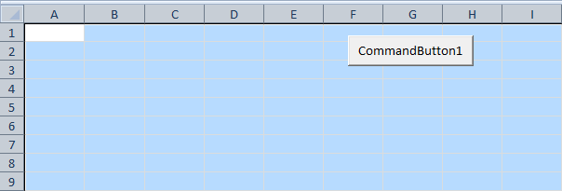

Note: because we placed our command button on the first worksheet, this code line selects the entire first sheet. To select cells on another worksheet, you have to activate this sheet first. For example, the following code lines select the entire second worksheet.

Worksheets(2).Activate  
Worksheets(2).Cells.Select

2. The following code line selects the second column.

Columns(2).Select

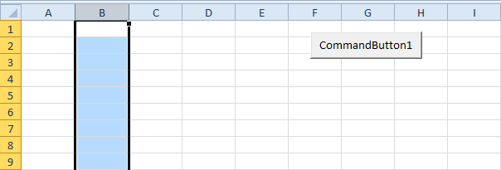

3. The following code line selects the seventh row.

Rows(7).Select

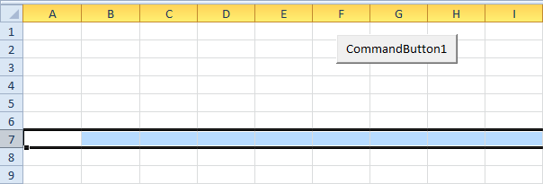

4. To select multiple rows, add a code line like this:

Rows("5:7").Select

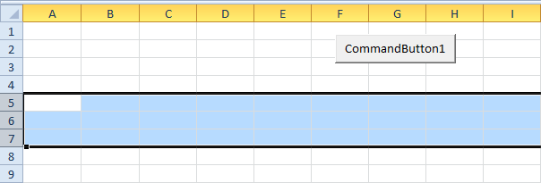

5. To select multiple columns, add a code line like this:

Columns("B:E").Select

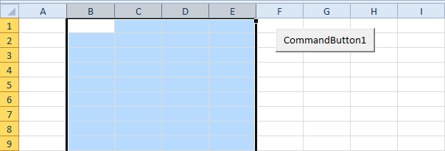

6. Be careful not to mix up the Rows and Columns properties with the Row and Column properties. The Rows and Columns properties return a Range object. The Row and Column properties return a single value.

Code line:

MsgBox Cells(5, 2).Row

Result:

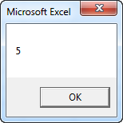

7. Select cell D6. The following code line selects the entire row of the active cell.

ActiveCell.EntireRow.Select

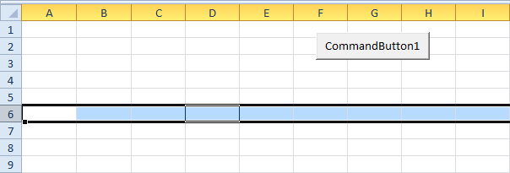

Note: border for illustration only.

8. Select cell D6. The following code line enters the value 2 into the first cell of the column that contains the active cell.

ActiveCell.EntireColumn.Cells(1).Value = 2

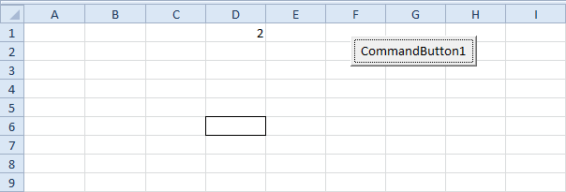

Note: border for illustration only.

9. Select cell D6. The following code line enters the value 3 into the first cell of the row below the row that contains the active cell.

ActiveCell.EntireRow.Offset(1, 0).Cells(1).Value = 3

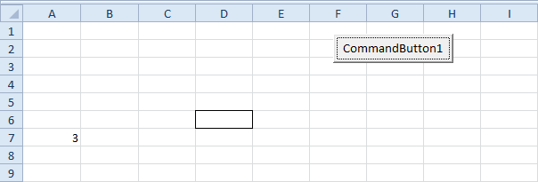

From Active Cell to Last Entry

This example illustrates the End property of the Range object in Excel VBA. We will use this property to select the range from the Active Cell to the last entry in a column.

Situation:

Some sales figures in column A. Assume that you will be adding more sales figures over time.

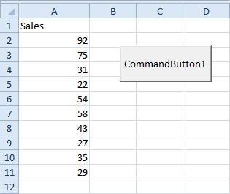

1. To select the last entry in a column, simply add the following code line:

Range("A5").End(xlDown).Select

Note: instead of Range("A5"), you can also use Range("A1"), Range("A2"), etc. This code line is equivalent to pressing the END+DOWN ARROW.

Result when you click the command button on the sheet:

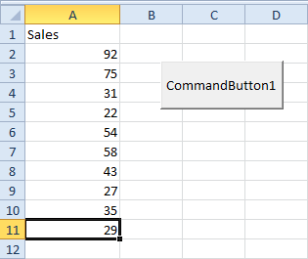

2. To select the range from cell A5 to the last entry in the column, add the following code line:

Range(Range("A5"), Range("A5").End(xlDown)).Select

Result when you click the command button on the sheet:

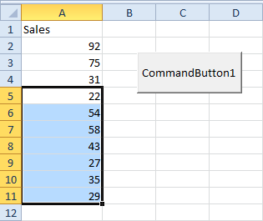

3. To select the range from the Active Cell to the last entry in the column, simply replace Range("A5") with ActiveCell.

Range(ActiveCell, ActiveCell.End(xlDown)).Select

Result when you select cell A2 and click the command button on the sheet:

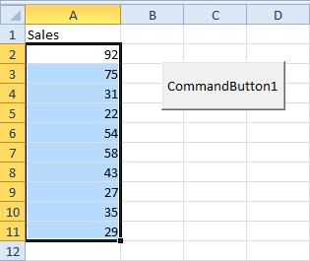

Note: you can use the constants xlUp, xlToRight and xlToLeft to move in the other directions. This way you can select a range from the Active Cell to the last entry in a row.